 | YEAR 12 Essentials Mathematics  Semester 1 2018  Test 5 – Data Collection  Total Marks: 31 marks  Name: ______________________ Total Time: 45 minutes    Full working out must be shown to get full marks.  Attempt all questions in the space provided  Resources allowed:  1 A4 page, (1 side) of hand written notes, ruler  Calculator |  | Mark  55
Question One |  | [4 marks; 1 each]
Classify each of the following data collections according to whether they are a sample or census.

- Favourite TV programs of secondary school students by surveying students in Year 8.

- Number of hours computer games played by you class at home each week by surveying each student in your class.

- Survey of first 40 customers at the opening of a new store to gauge customer satisfaction.

- The most popular colours for cars sold in the last month in Western Australia, taken from the registration board database of all cars registered in the last month.

Question Two |  | [3 marks; 1 each]
Give an example of how each of these sampling methods can be conducted.

Random sampling:

Systematic sampling:

Self-selecting sampling:

Question Three |  | [6 marks; 1 each]
Answer the following questions about the scatterplot below.

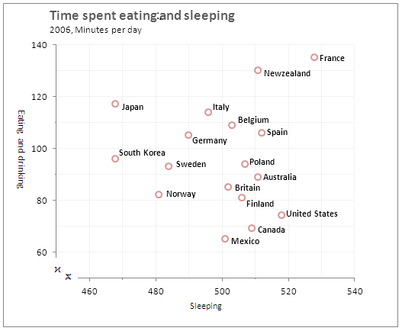
- Which country spends the least amount of time eating and drinking?

- Which country spends the most time sleeping?

- Which country comes fourth in spending the most time eating and drinking?

- After Canada which country is next when it comes to eating and drinking?

- Which country spends less time than Sweden eating and drinking and less time sleeping than Mexico?

- Which country spends less times sleeping and more time eating and drinking than Italy?

Question Four |  | [4 marks; 1 each]
Give one advantage and disadvantage of conducting a census and sample.

 | Census | Sample
Advantage
Disadvantage

Question Five |  | [3 marks]
A survey was conducted to find the satisfaction rating of the service provided at a local café. The day of the survey coincided with a hail storm which affected the area. The survey conducted was self-selecting and five people participated. All of the participants were 100% satisfied with the service provided. Explain why this data is misleading and unreliable, give two reasons. Provide an example of how data could be collected in a more reliable manner.

Question Six |  | [1 mark]
A new product is being launched which claims to hide vegetables within its meal while maintaining its appeal to young children. A survey is conducted at these various locations, an accounting office in the city, a retirement village, a primary school and a fine dining restaurant. Explain how to best use the data.

Question Seven |  | [7 marks; 1, 1, 3 and 2 marks]
The number of jam jars sold at a supermarket in a northern suburb of Perth was recorded as well as the number of CDs sold at a record shop in a southern suburb of Perth over a number of days. The scatterplot for the data was produced below.
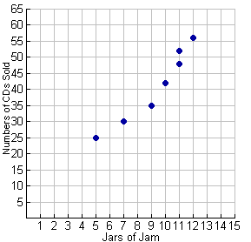
- Over how many days was the data collected?

- Draw in a line of best fit for the scatterplot.

- Describe the association between the variables in terms direction, form and strength.

- What conclusion can you make about the number of jars of jam sold and number of CDs sold at these stores?

Question Eight |  | [4 marks]
A stratified sample of 75 students is to be selected from the student population of a school. If the school consists of 256 year sevens, 222 year eights, 175 year nines, 198 year tens, 156 year elevens and 98 year twelves, how many of each year group should be in the sample for it to reflect the proportion in each year group?

Question Nine |  | [5 marks; 1, 1 and 3 marks]
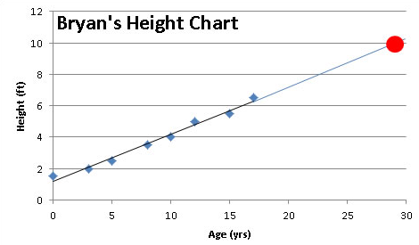
- For the scatterplot above, use the line of best fit to predict Bryan’s height when he is 25 years old.

- To convert feet (ft) to centimetres (cm) we multiply the height in feet by 30.48. What would Bryan’s height be in centimetres?

- Make a comment on the reasonableness of this prediction, giving two reasons why this would be a reasonable/unreasonable prediction.

Question Ten |  | [13 marks; 4, 2, 2, 1, and 4 marks ]
A statistician was asked to investigate whether countries with higher levels of consumption of a particular foodstuff tended to have a higher death rate due to heart disease. The following information was obtained for 12 countries.

 | CONSUMPTION OF FOODSTUFF  kg per person per year | DEATHS DUES TO HEART DISEASE  Per year per 100 000 of population
Country A | 57 | 299
Country B | 13 | 154
Country C | 51 | 152
Country D | 48 | 295
Country E | 35 | 208
Country F | 9 | 100
Country G | 21 | 175
Country H | 10 | 120
Country I | 46 | 202
Country J | 64 | 290
Country K | 38 | 156
Country L | 29 | 250

- Draw a scatterplot on the axis below.

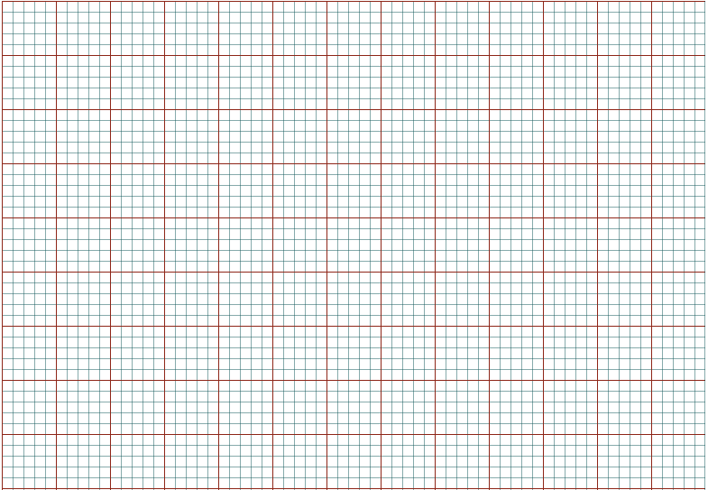
- Does there appear to be a relationship between the two variables? If so, describe it.

- If there is an association, is it a causal relationship or not? If not, suggest other factors that we might need to consider.

- Draw in a line of best fit on your scatterplot.

- Use your line of best fit to show how how this can be used to predict the deaths due to heart disease given the consumption of food stuffs is 25 kg per person per year. What is your prediction, make a comment on how reliable this prediction is and why you think so.

